1. **What is the Gator Good Campaign?**

An effort to push UF students and alum to achieve greater achievements and connections by making moral, long term decisions that not only benefit themselves but also the people and things around them.

1. **Why was it established?**

To inspire and educate UF students and alumni to do greater things in the world and celebrate past successes. According to Kimberly Hallman, the spokeswoman for the marketing agency 160/90, the purpose of the campaign is “to turn the lens of the camera away from the campus itself”.

1. **What are the areas of focus of Gator Good?**

There are 8 areas of focus: Early Childhood Development, Renewable Energy, Food Saftey and Sustainability, Medicine and Global Health, The Brain, Biodiversity and The Earth, Cybersecurity, Drones and Autonomous Vehicles.

1. **What type of research is being conducted concerning the brain?**

Research involving safer athletics to avoid concussions, further innovation to detect concussions right when they happen, and a few research projects working towards solutions for Parkinson’s disease.

1. **Identify at least 10 researchers associated with brain research at UF. Document their names, titles and UF affiliation.**
2. Dr. Jay Clugston, a UF team doctor and assistant professor of community health and family medicine
3. Dr. Russell Bauer, a professor at UF College of Public Health and Health Professions
4. Aliyah Snyder, a graduate assistant at UF College of Public Health and Health Professions
5. Ron Hayes, an employee at Banyan Biomakers, concussion research for UF Football
6. Chris Haas, professor at UF College of Health and Human Performance
7. Michael Okun - Neuroscientist, TEDxUF Speaker
8. Kelly Foote, Neurosurgeon Doctor, TEDxUF Speaker
9. Kieth Peters, head of the Department of Radiology at UF, leader of the NCAA/DOD Grand Alliance
10. Dwayne Dubose, UAA Research coordinator and certified phlebotomist with the UF athletic association.
11. Breton Asken, Clinical Psychology Research coordinator, an employee of UF Concussion center
12. **Find at least 2 examples of papers published in peer-reviewed journals by UF brain researchers.**
    1. The Future of Concussion, in the journal of Seminars in Pediatric Neurology. July 2019, Vol. 30, 128 by Aliyah Snyder
    2. Exposure of cyclosporin A in whole blood, cerebral spinal fluid, and brain extracellular fluid dialysate in adults with traumatic brain injury, in the Journal of Neurotrauma. Sept 1, 2013, Vol. 30 Issue 17, p1484, 6 p., by Ron Hayes
13. **Identify at least 2 non-UF affiliated brain researchers. Document their names, titles and contact information.**
    1. Yukai Chang, distinguished professor in Department of Kinesiology, University of North Carolina [ykchang.new@gmail.com](mailto:ykchang.new@gmail.com)
    2. Jeffrey Labban, professor in the Department of Kinesiology at the University of North Carolina,[jdlabban@uncg.edu](mailto:jdlabban@uncg.edu)
14. **Include at least 4 screen captures of social media posts about Gator Good brain research.**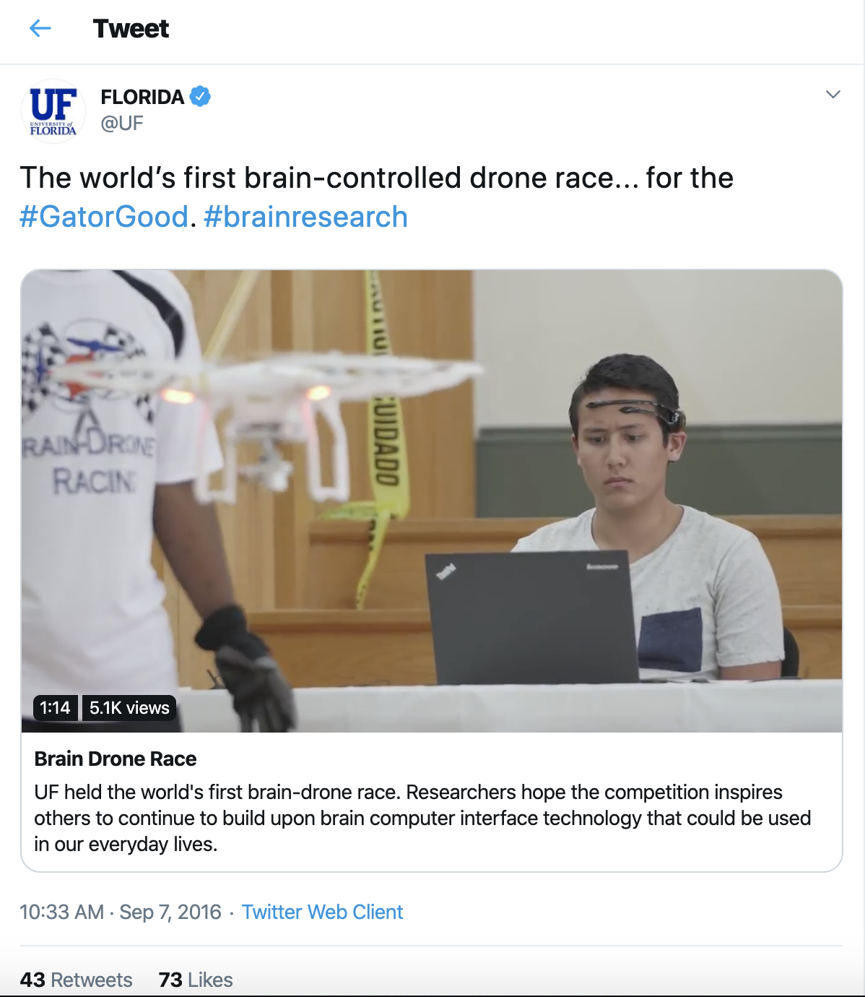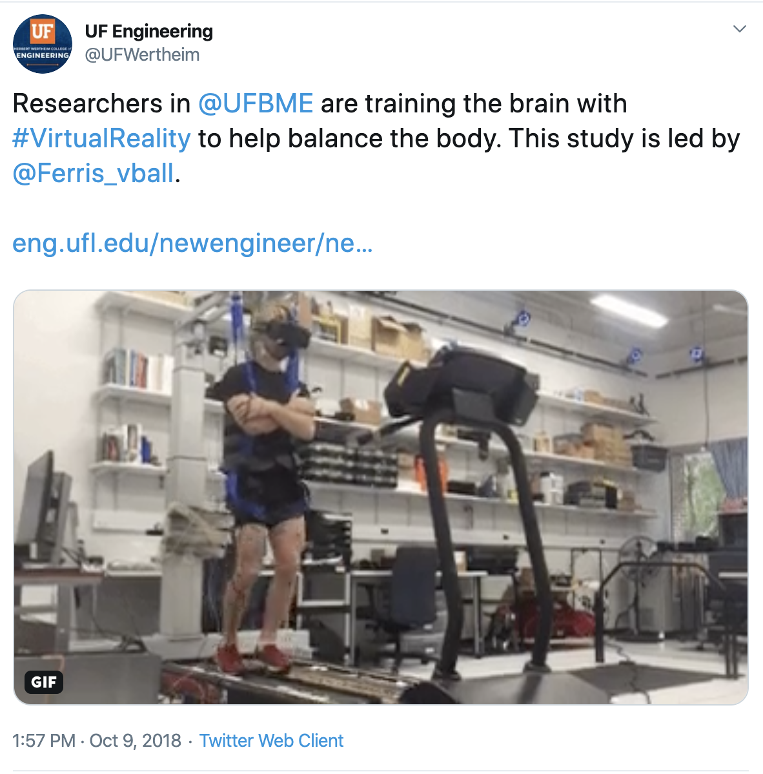

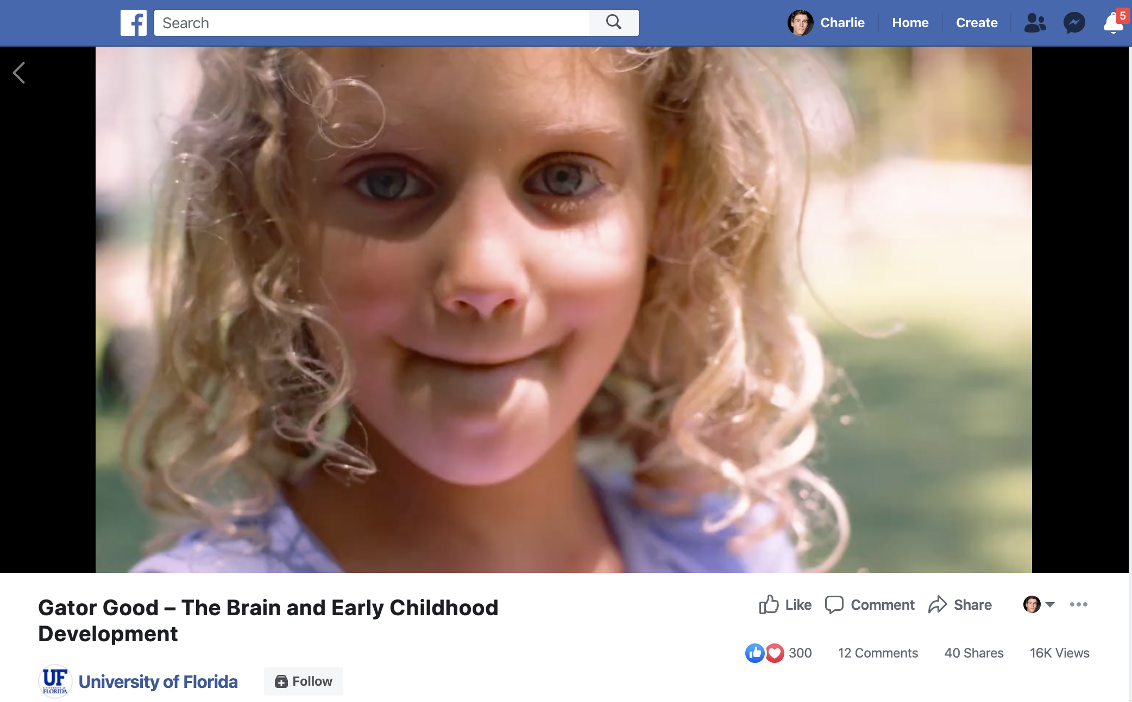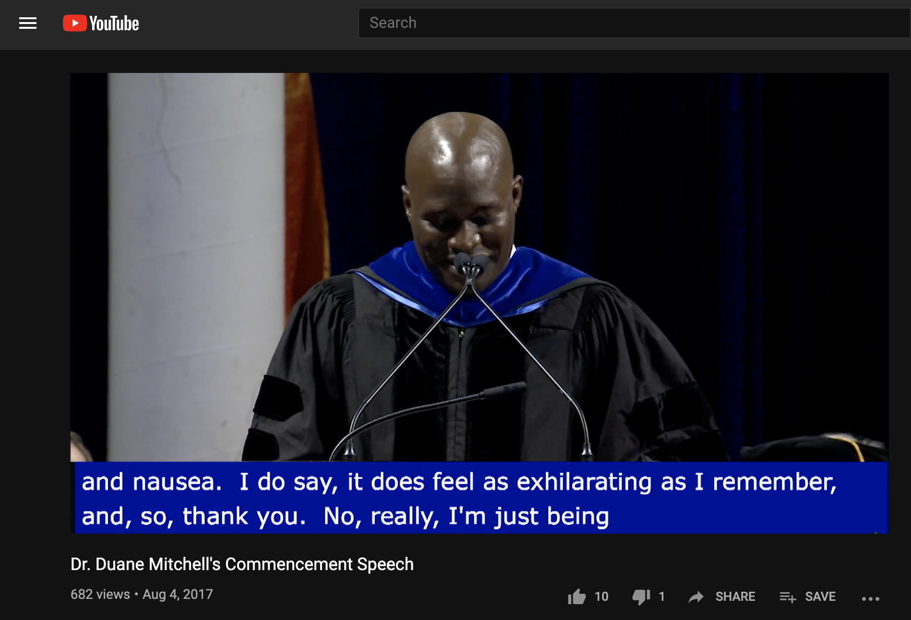

**Works Cited**

Brophy, G. M., Mazzeo, A. T., Brar, S., Alves, O. L., Bunnell, K., Gilman, C., … Bullock, R. (2013). Exposure of Cyclosporin A in Whole Blood, Cerebral Spinal Fluid, and Brain Extracellular Fluid Dialysate in Adults with Traumatic Brain Injury. Journal of Neurotrauma, 30(17), 1484–1489. doi: 10.1089/neu.2012.2524

Snyder, A. R., & Giza, C. C. (2019). The Future of Concussion. Seminars in Pediatric Neurology, 30, 128–137. doi: 10.1016/j.spen.2019.03.018

UFHealth. (2015, October 23). Gatorade Fuels Research That is Changing Lives: Dr. Chris Hass. Retrieved January 15, 2020, from <https://www.youtube.com/watch?v=0APCGyV2Ukw>

Tedx Talks. (2012, April 17). How to control the brain: Michael Okun and Kelly Foote at TEDxUF. Retrieved January 15, 2020, from <https://www.youtube.com/watch?v=7udZ5ux0dYE>

Florida Gators (March 31, 2015). HEADY AMBITIONS The University of Florida is involved in a landmark concussion study in alliance with the NCAA and U.S. Department of Defense. Retrieved Hanuary 15, 2020, from <https://floridagators.exposure.co/heady-ambitions>

ABC 10 News. (2015, July 30). Local company preparing 'game-changing' tool for detecting concussions. Retrieved from <https://www.youtube.com/watch?v=MjfZJ_uzKcM>

Business Report of North Central Florida. (2014, September 3). UF rolls out university-wide rebranding campaign: For the Gator Good. Retrieved January 15, 2020, from <https://gainesvillebizreport.com/uf-rolls-out-university-wide-rebranding-campaign-for-the-gator-good/>

Chang, Y., Labban, J., Gapin, J., & Etnier, J. (2012). The effects of acute exercise on cognitive performance: A meta-analysis. Brain Research, 1453, 87–101. doi: 10.1016/j.brainres.2012.02.068